Requirements Specification
For Solidaridad

Project Name Solidaridad Sugar Sustainable
Date 30-01-2018

Commercial in Confidence
© Solidaridad

The material contained herein is provided by

Solidaridad

Under the terms of Non-Disclosure and Confidentiality, included here as a Schedule to this Agreement, such confidential information must not be reproduced or disclosed to 3rdparties without consent in writing from the Managing Director of Solidaridad

All rights reserved.

Solidaridad, and its affiliated companies, reserve all respective Intellectual Property Rights that may apply to the contents of this document and/or associated discussions that may transpire, whether or not the intellectual property is specifically mentioned within, or implied by this document. Associated Intellectual Property Rights include those relating to patents, copyright, trademarks, registered and unregistered designs, and/or all other statutory, common law, case law, and/or any other rights to which both parties may be respectively entitled to in the Indian and/or any other country or national or international body where ever it may be located.

Table of Contents

1 Introduction 6
2 Sitemap 7
2.1 Front-End 7
2.2 Admin Area 8
2.3 Farmer Area 8
2.4 Solidaridad Officer Area 9
2.5 Factory Representative Area 9
2.6 Certification Body/Buyers Area 10
3 Front-End System Requirements 11
3.1 Global Requirements 11
3.1.1 Functional Requirements 11
3.1.2 User Interface Design 12
3.1.3 Functional Requirements 12
3.2 Sign Up / Login (M002) 13
3.2.1 User Interface Design 13
3.2.2 Log in: 13
3.2.3 Functional Requirements 14
3.3 M003 Admin Dashboard 15
3.3.1 User Interface Design 15
3.3.2 Dashboard: 15
3.3.3 User Menu : 15
3.3.4 Add representative: 16
3.3.5 Representative view/edit/delete: 16
3.3.6 Crop view/edit/delete: 17
3.3.7 Add crop: 17
3.3.8 Questionnaire’s create: 18
3.3.9 Questionnaire’s Modify/Delete: 18
3.3.10 Add questionnaire’s section: 19
3.3.11 Add the Questionnaire’s Types: 19
3.3.12 Add questionnaire’s linking: 20
3.3.13 Add Certification Body: parameters name, year and crop. 20
3.3.14 Certification bodies view/edit/delete: 21
3.3.15 Best Practices: 21
3.3.16 Add best practices : 22
3.3.17 Best practices edit/delete: 22
3.3.18 Companies: 23
3.3.19 Add companies: 23
3.3.20 Pest and Diseases: 24
3.3.21 Reports: 24
3.3.22 FAQ’s : 25
3.4 M004 Farmer Area 25
3.4.1 Farmer registration: 25
3.4.2 Dashboard: 26
3.4.3 Questionnaire’s: 26
3.4.4 Pests and Diseases: 27
3.4.5 FAQ: 27
3.5 M005 – Representative Area 28
3.5.1 Dashboard: 28
4 Data Dictionary 29
4.1 Company 29
4.2 User 30
4.3 UserType 31
4.4 CompanyType 32
4.5 Factory 32
4.6 QuestionType 34
4.7 QuestionSection 34
4.8 Question 35
4.9 QuestionOption 36
4.10 QuestionOptionLink 36
4.11 FarmerEvaluation 36
4.12 Farmer 37
4.13 Farmers Land Details 38
4.14 Certification 40
4.15 AppModules 40
4.16 UserPermission 41
4.17 State 41
4.18 District 41
4.19 Taluk 42
4.20 Village 42
4.21 Crop 43
4.22 Irrigation 43
4.23 Address 43
5 Database Schema 44

Version History (of documentation)

Version | Date | Written by | Checked by | Authorized by
1 | 27/01/2018 | Dhananjay | - | -
 |  |  | - | -

Introduction

This document specifies requirements for the Sugar Sustainable web application. The requirements are viewed from a page-level perspective that is organised into modules with ‘M’ codes. Use cases are produced in order to visualise the problem and solution. From these, requirements are derived through discussion.

Requirements are split into 3 categories:

• User Interface Layout
• Functional Requirements
• Non-Functional Requirements

The user interface layout is represented by a simple diagram that indicates the positioning of functional controls and key design features on the screen. Functional requirements relate to the functional behaviour of the module. An example of a functional requirement would be:

“Upon clicking the ‘Delete’ button, an alert box is displayed containing an Are You Sure prompt.”

Supplied with functional requirements is a diagrammatical representation of the process logic of the module if it is very complex.
Non-functional requirements are those that are perhaps assumable or related to quality, rather than directly related to the functionality of the system. An example of a non-functional requirement is a performance requirement such as:

“The system must not pause to process the Activity for more than 30 milliseconds.”

Or a quality requirement such as:

“The navigation menu must not display gaps upon customisation by the user.”

Or a visual design requirement:

“The text ‘Solidaridad Sugar Sustainable’ must be positioned at the top of the screen as a title.”

It is important to classify requirements in this way to reduce ambiguity, the main threat to the performance of requirements analysis.

Sitemap

Front-End

User Flow

Home Page

What We Do
About Us
Contact Us
Log In

Users

Farmer
Solidaridad Officer
Factory Worker
Buyer
Admin

Dashboard

Admin Area

Log In

Dashboard Home

Users
Crop
Best Practices
Questionnaire’s
Reports
Companies

FAQ’s

Add/Create
Edit
Delete
View

Farmer Area

Register

Log In

Dashboard Home

Crop
Best Practices
Questionnaire’s
FAQ’s
Profile

Edit
View

Solidaridad Officer Area

Log In

Dashboard Home

Best Practices
Questionnaire’s
FAQ’s
Profile

Edit
View

Factory Representative Area
Log In

Dashboard Home

Users
Profile

Farmer

Edit
View

Certification Body/Buyers Area
Log In

Dashboard Home

Profile

Crop

Edit
View

Front-End System Requirements

Global Requirements

Functional Requirements

Throughout the data entry pages, all data updates must be logged with the time, date, user and page of update. This includes background saves such as when switching between sub forms as well as when clicking “Update Database” directly.

To edit data from the data entry pages, the user must be logged in and have the right to edit the data of the pages. Without logging in, the user may only view the data.

All front-end data entry screens will carry explanation text on all field labels.

Email Reminders for Users before due date

Notifications from admin for all users

Email notification on Request to create an organisation (to admin), registration, approval of users, approval of organisations.

Supported file types: jpeg, jpg, png, gif, doc, docx, pdf, avi, flv, mpeg
M001 – Portal Homepage

User Interface Design

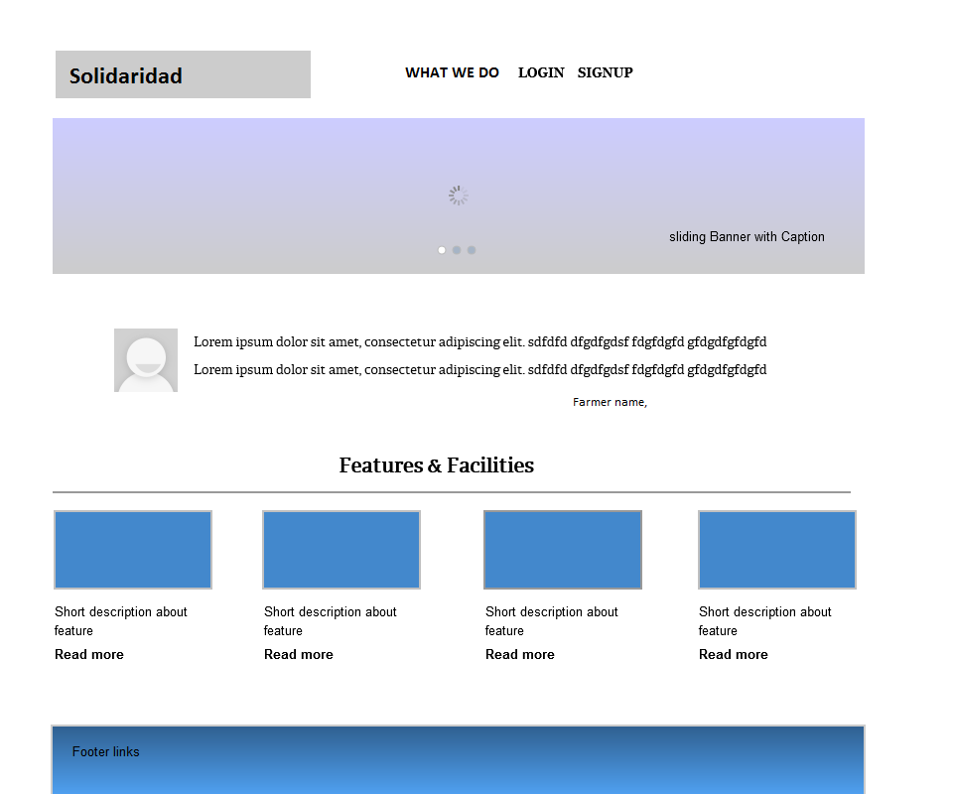

Functional Requirements

Links
What We Do
Portal Homepage
User Login / Signup

User registeration

This page serves as an introduction to the system. The content managed area is intended for introductory text and direct links to Contents.

A managed Slider Area where animating banners can be uploaded from backend. (Super Admin)

Sliding Testimonial area below the Banner Section: Testimonials can be added from backend (Super Admin)

Features and Facilities: This contents explains the Main features and facilities of the system. These blocks will scroll from start to end in a loop. The content and images are manageable from backend (Super Admin)

Sign Up / Login (M002)

User Interface Design

Register: Farmer will register with First Name, Last Name, Email ID and Password(all are mandatory fields) to access the dashboard.
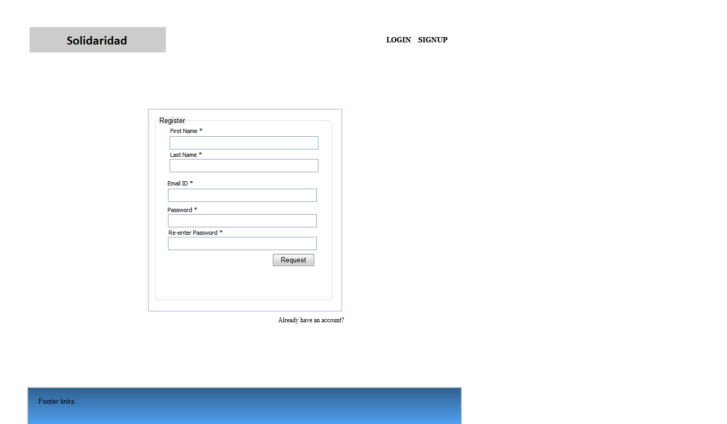

Log in:

User have to enter username as email and password which is entered during registration(both are mandatory fields).
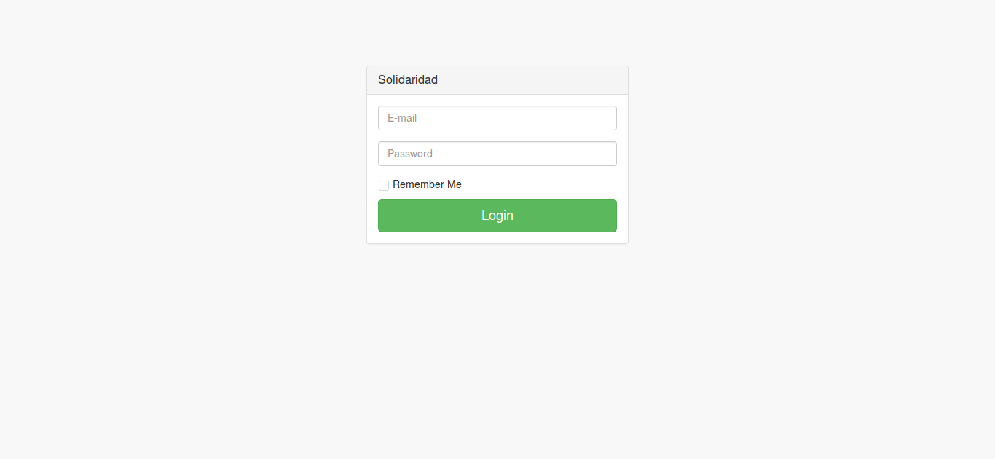

Functional Requirements

Any User can register to an Organisation through this interface. User will reach this page in two ways 1) From Homepage portal Signup Link 2) When clicking on Invitation Link (In this case Organisation name , and Email ID values are already present).

User can Go to login page (M002) on clicking link “Already have an Account ?”

Admin approval for new user registration : User can login only after approved by the Admin

Mandatory : All fields

M003 Admin Dashboard

User Interface Design
Functional Requirements

Dashboard:
Dashboard will display the Tasks in different status. Created by the admin and Solidaridad Officers, Farmers yields and progress etc. 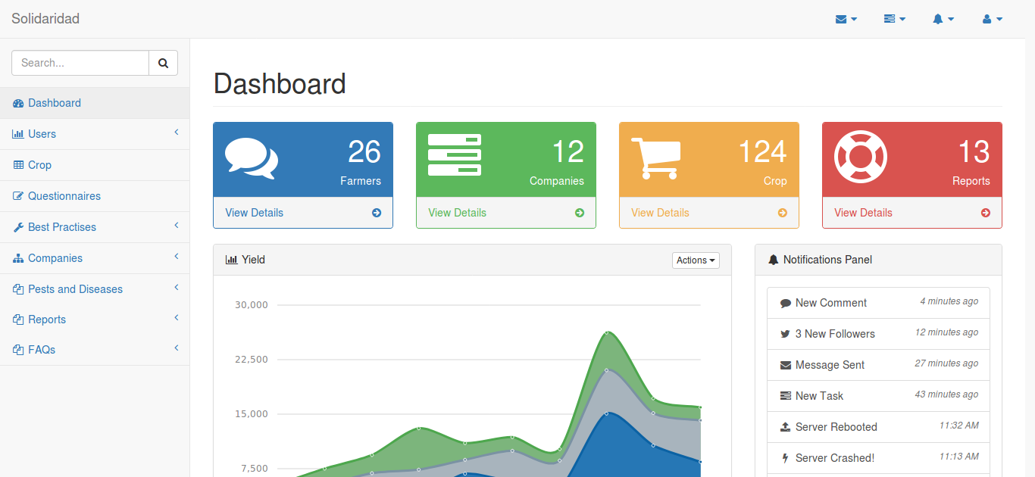

User Menu :

User menu consist of farmers, Solidaridad officers, Factory Representative, Certification body/Buyer etc.
View/edit/delete: admin can able to edit details, i.e when he clicks on edit button popup will be opened with respective values can be edited and saved.
For deletion on clicking of delete button pop will opted to confirm the delete action(yes or no).
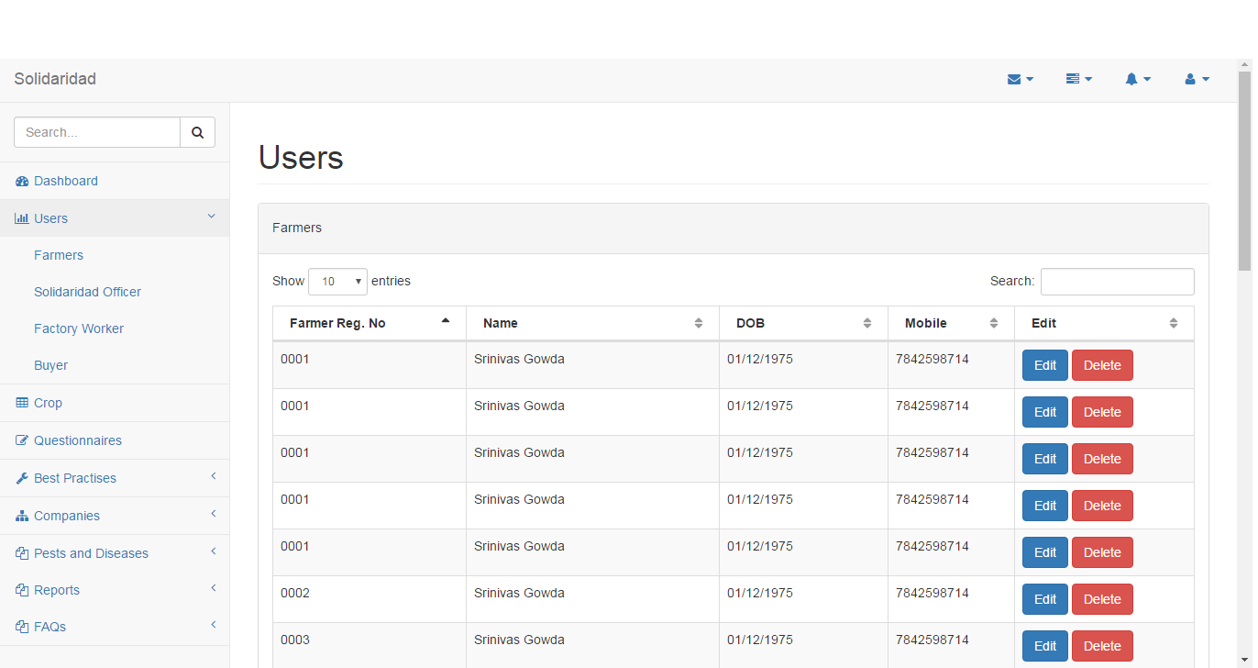

Add representative:
we can add representatives like solidaridad, factory and others respectively. Details to be entered Name, Address, Phone number, Education, Experience etc.
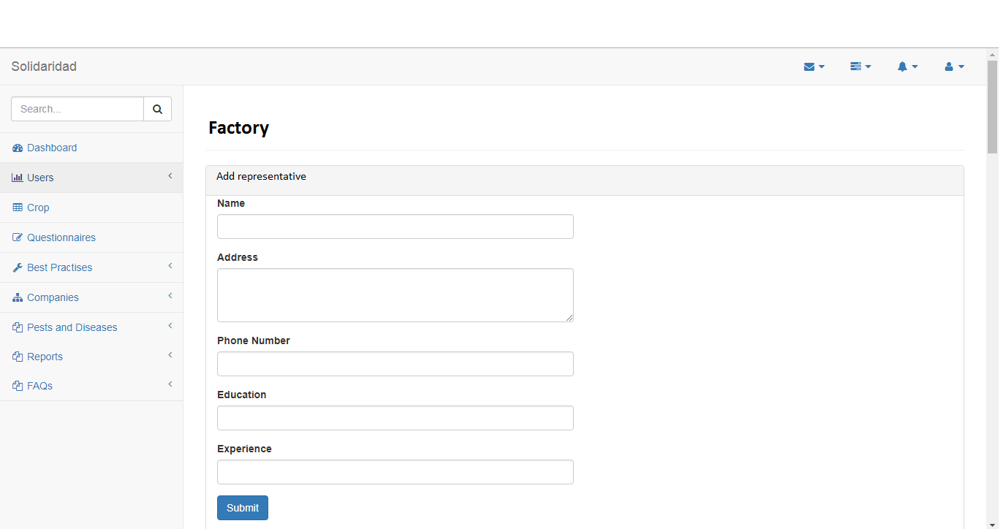

Representative view/edit/delete:
view the existing representatives, by clicking edit button popup displayed with values, so values updated and saved.
For deletion on clicking of delete button pop will opted to confirm the delete action(yes or no).
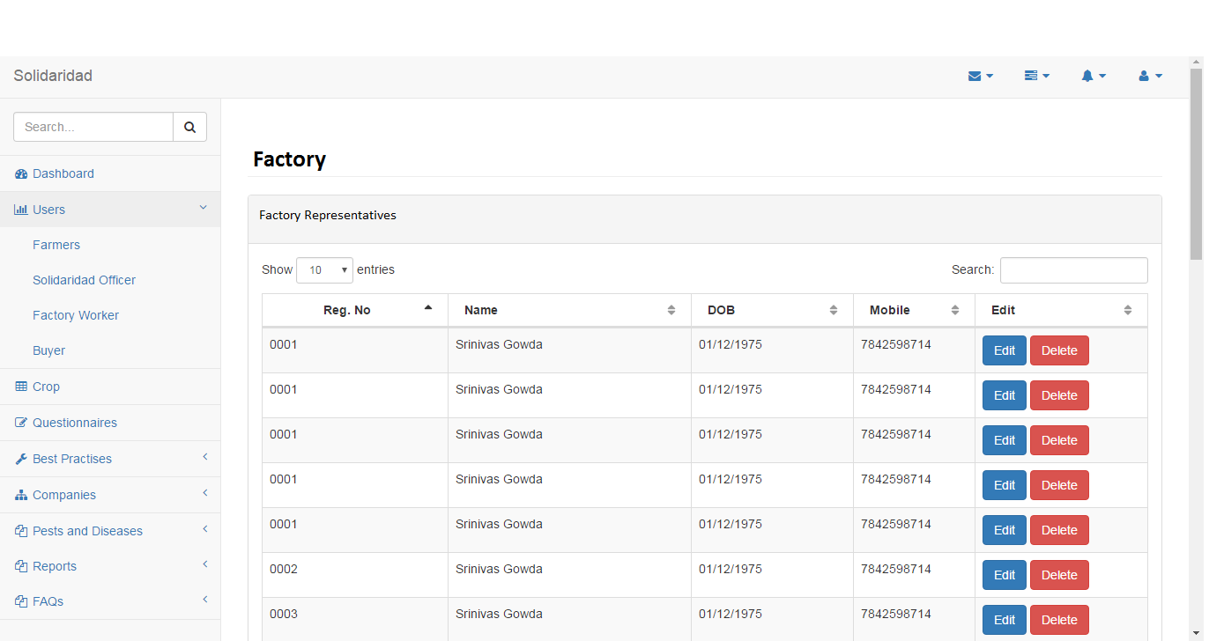

Crop view/edit/delete:
view/edit/delete: all crops displayed, by clicking edit button popup displayed with values, so values updated and saved.
For deletion on clicking of delete button pop will opted to confirm the delete action(yes or no).
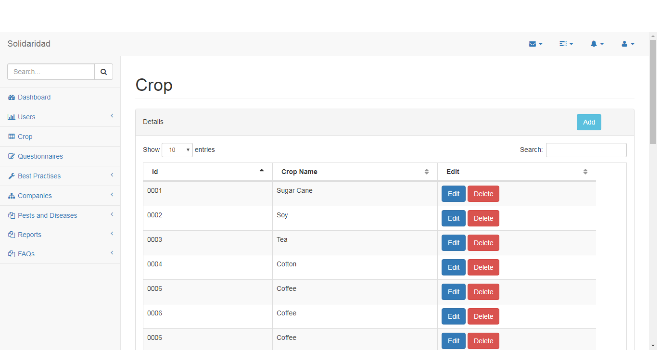

Add crop:
Enter the parameter crop name to create the crop.
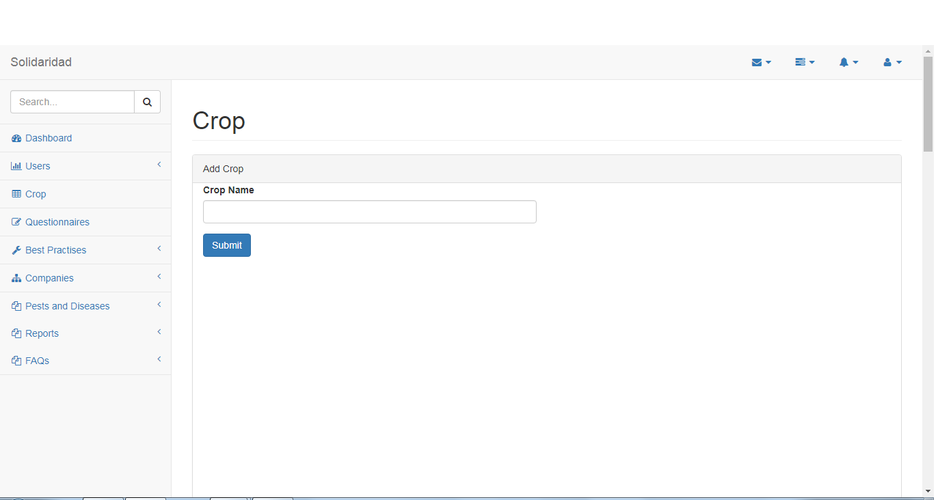

Questionnaire’s create:

Creating questionnaire’s: parameters section type, question type(M, P, D,L), question, Complies, Complies score, Minor-complies, Minor-score, non-compliant, non-compliant score, not-applicable, not-applicable score, Guidance and Checklist(All are mandatory fields).
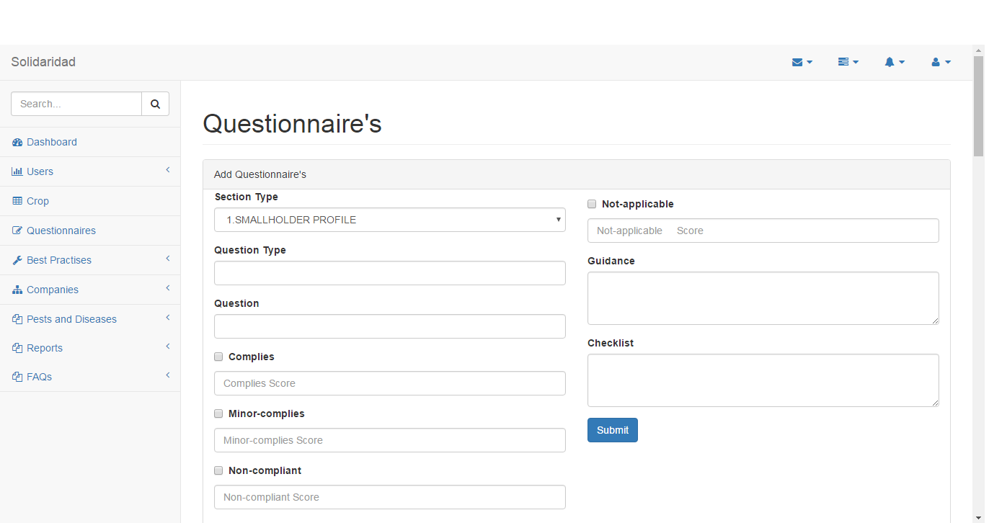

Questionnaire’s Modify/Delete:
view the questionnaire’s and by clicking edit button popup displayed with values, so values updated and saved.
For deletion on clicking of delete button pop will opted to confirm the delete action(yes or no).
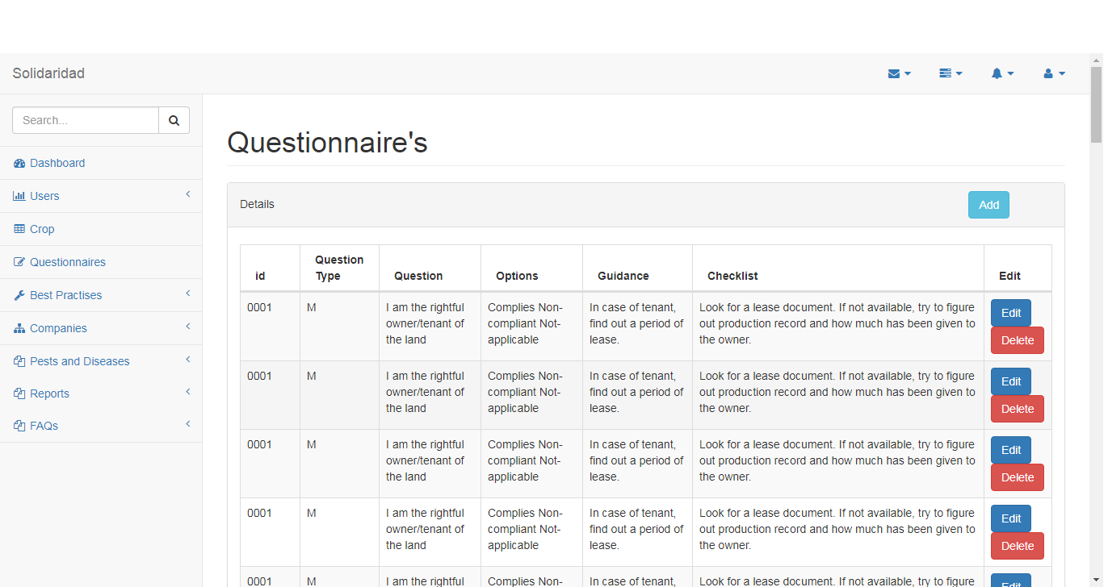

Add questionnaire’s section:
parameters section name(Small Holder profile, Labour and community rights etc.), certification body and description.
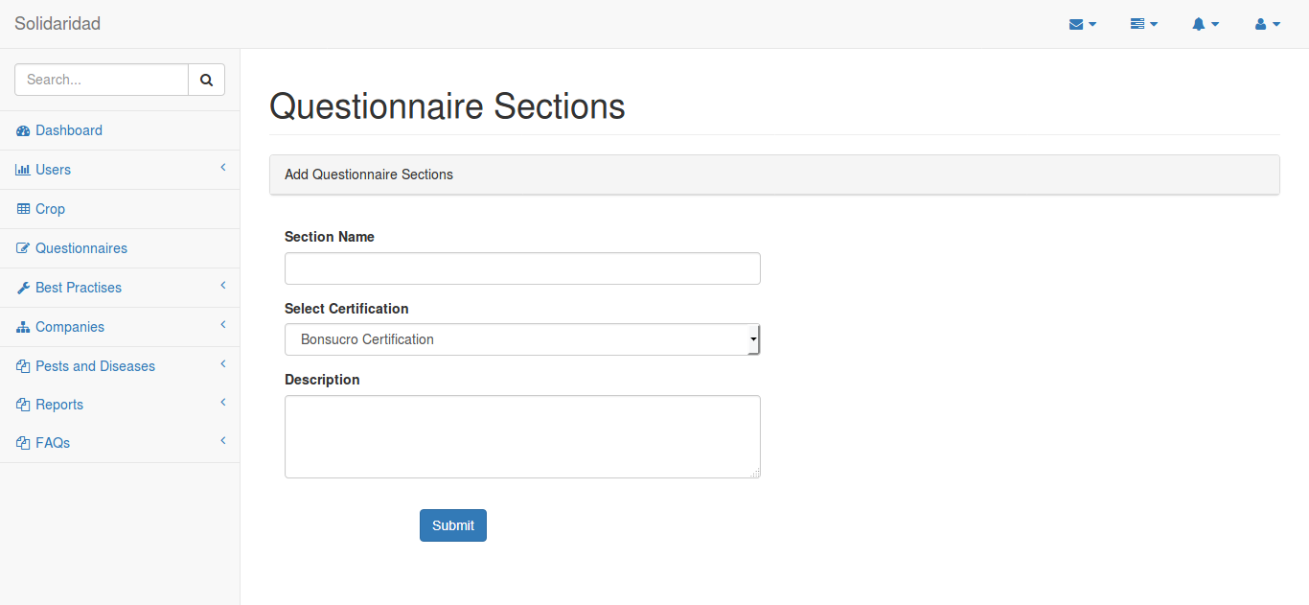

Add the Questionnaire’s Types:
parameters type name, type abbreviation of The question (M, P, D,L) and descrption.
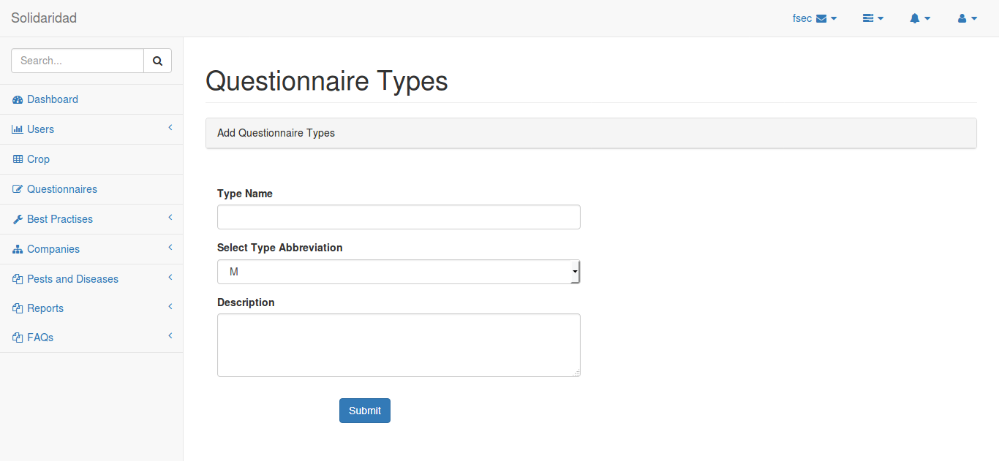

Add questionnaire’s linking:
parameters certification body, section name, question. By linking the questionnaire, we calculate the scores for different certification bodyies.

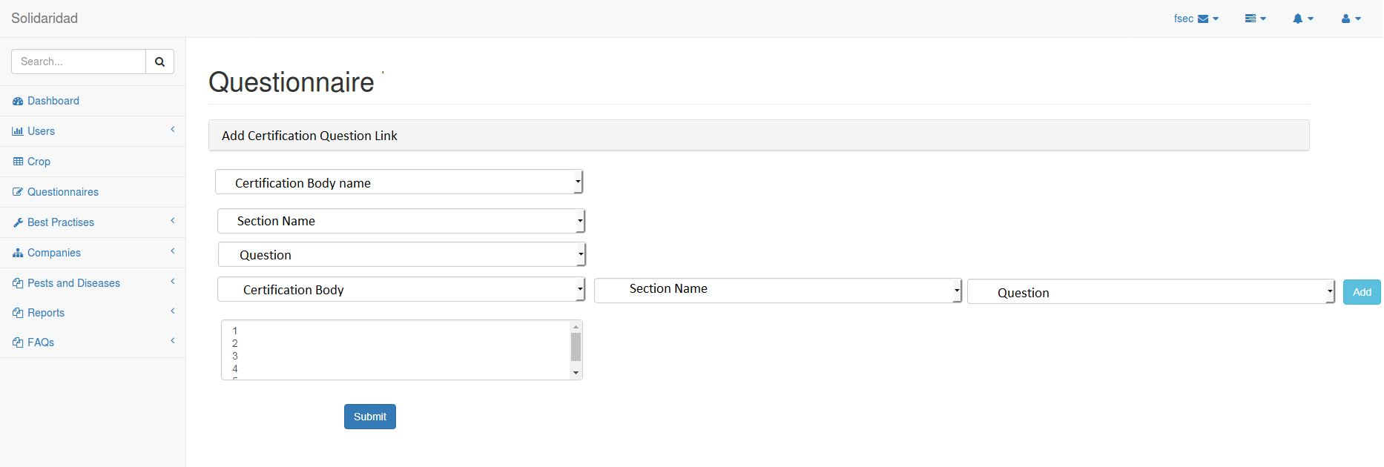

Add Certification Body: parameters name, year and crop.
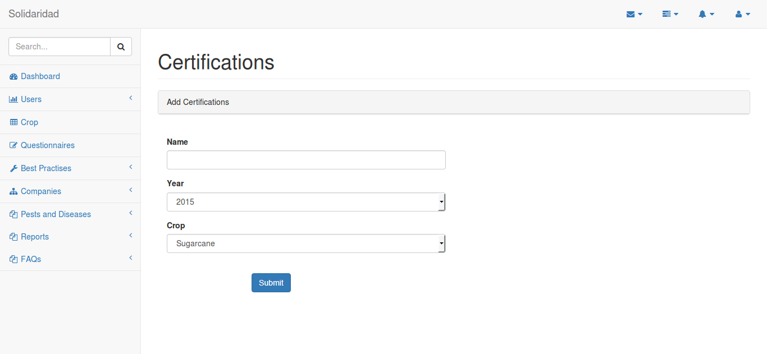

Certification bodies view/edit/delete:
view certification bodies and by clicking edit button popup displayed with values, so values updated and saved.
For deletion on clicking of delete button pop will opted to confirm the delete action(yes or no).
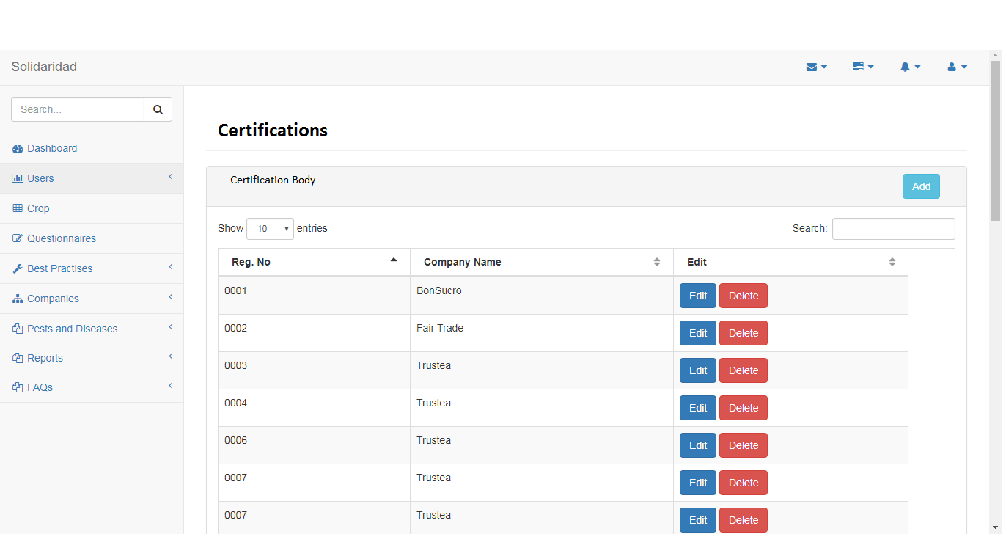

Best Practices:
Information of the points and steps to be followed for the best sugar cane yield.
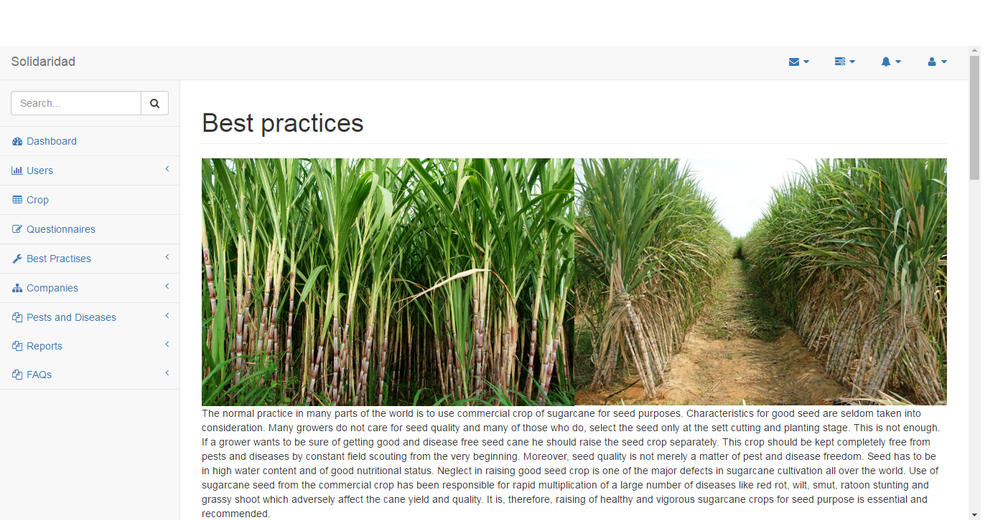

Add best practices :
creating best practices for crop, parameters images and descrption.
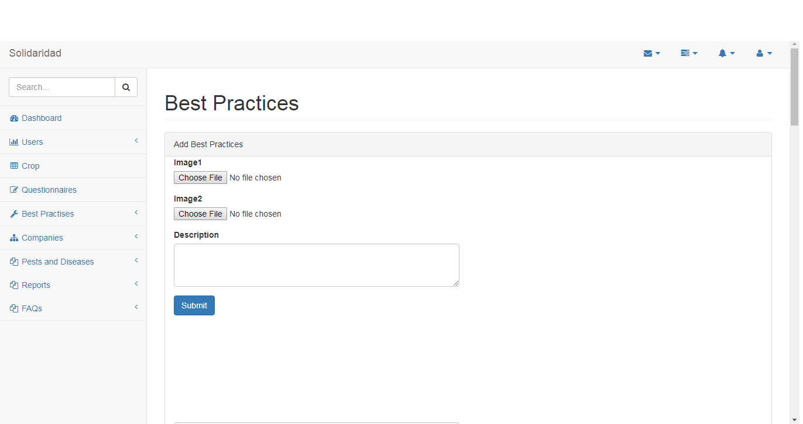

Best practices edit/delete:
view details and by clicking edit button popup displayed with values, so values updated and saved.
For deletion on clicking of delete button pop will opted to confirm the delete action(yes or no).
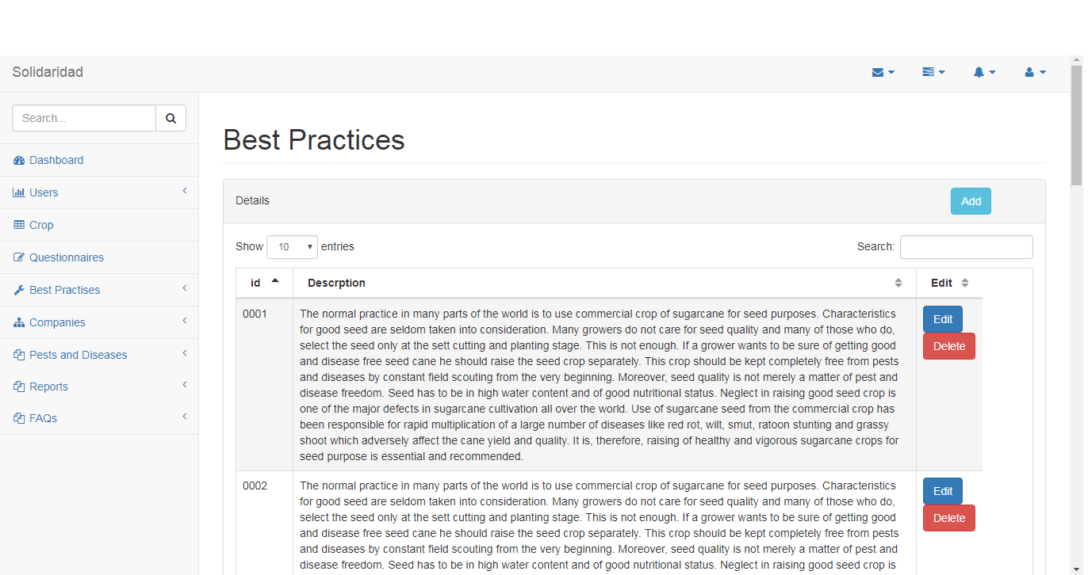

Companies:
Creating, modifying and deleting of Certification Bodies/Buyers, Factories etc.
Edit/delete Companies by clicking edit button popup displayed with values, so values updated and saved.
For deletion on clicking of delete button pop will opted to confirm the delete action(yes or no).
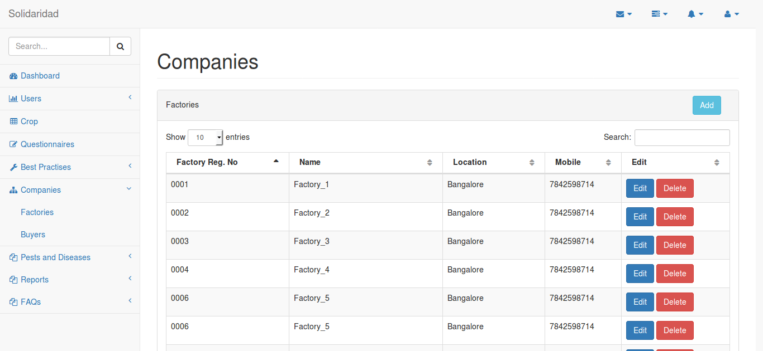

Add companies:
parameters company name, address, phone number and website etc.
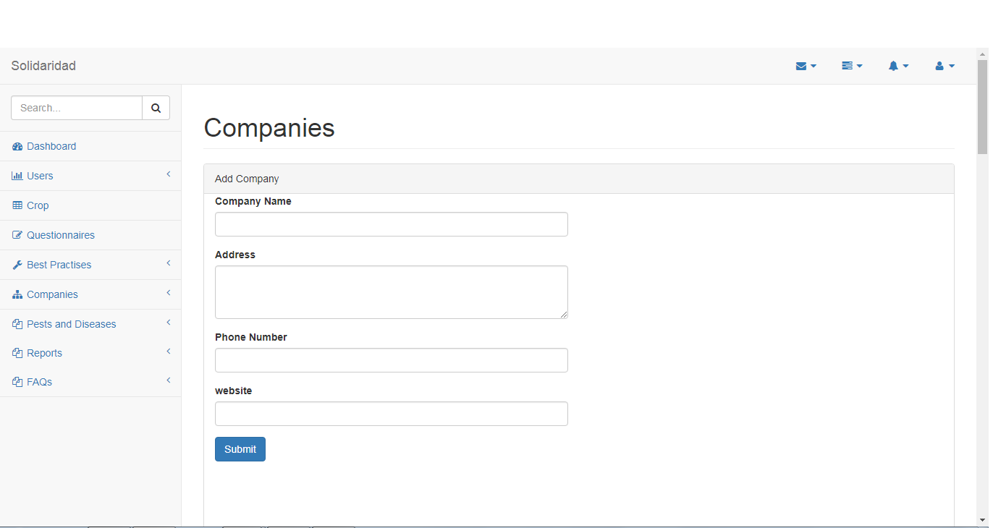

Pest and Diseases:
Information of pest and diseases that can occur for respective crops
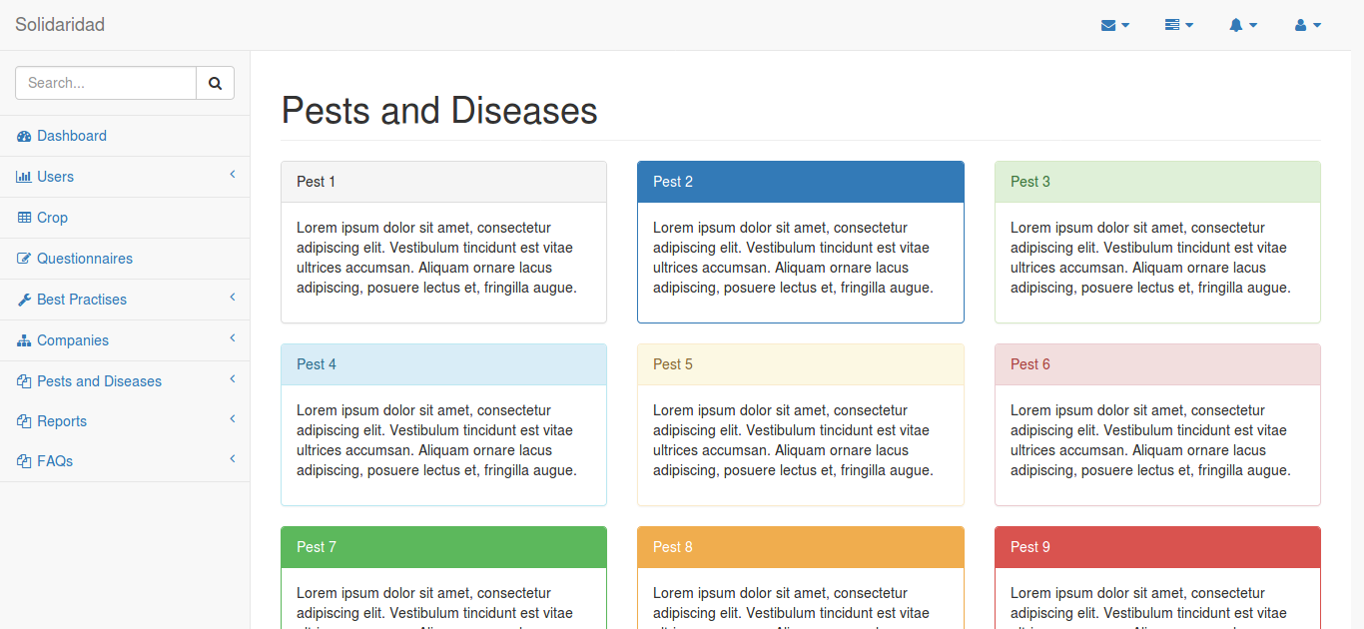

Reports:
Creating the reports using available data to CSV,XLSX or PDF format.
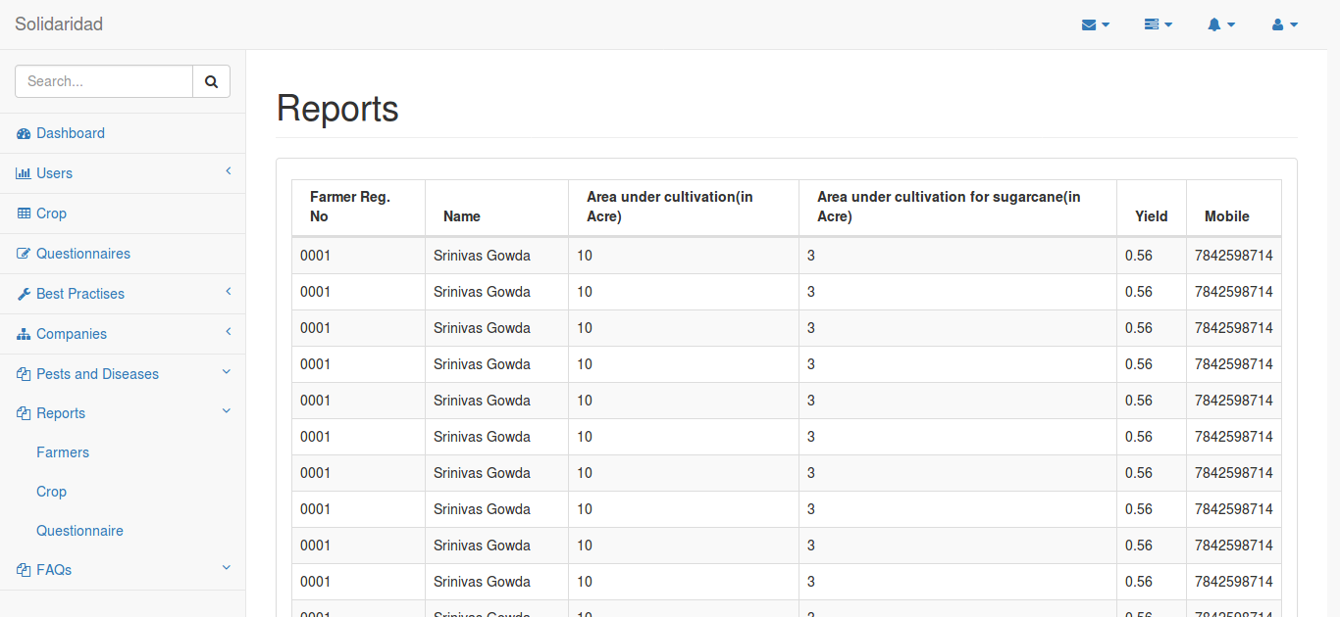

FAQ’s :
Frequently asked questions

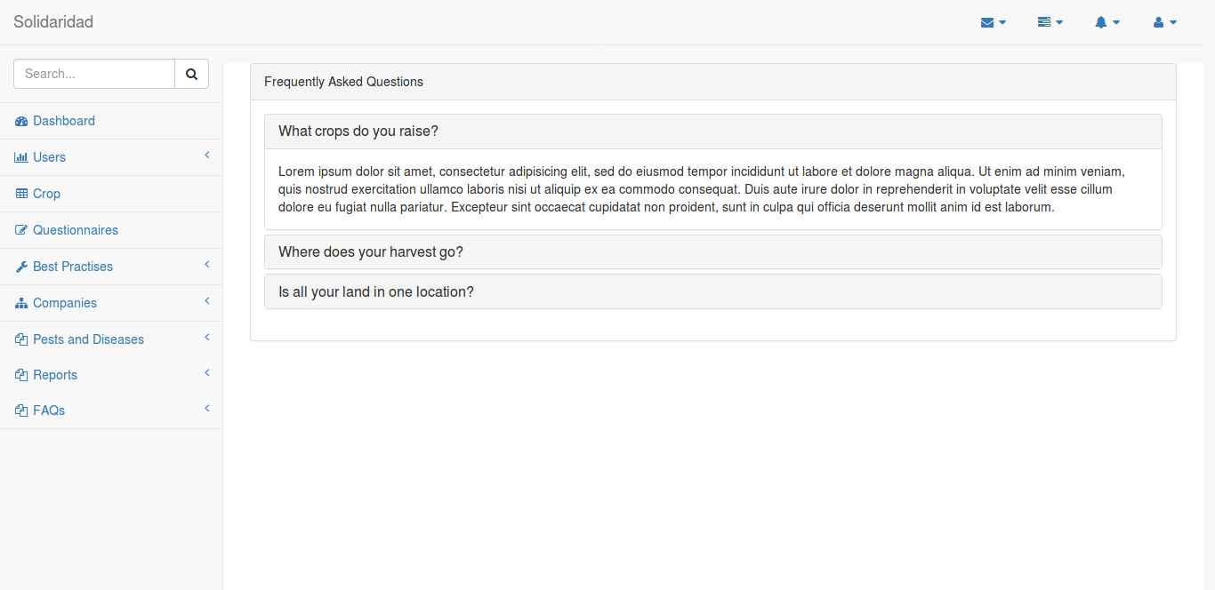

M004 Farmer Area

Farmer registration:
Parameters user details – name, mobile, UIN, year of birth, address etc. farmer details - farmer id, crop etc. land details – Year, total area under cultivation, area of land under production of sugarcane(hectares).
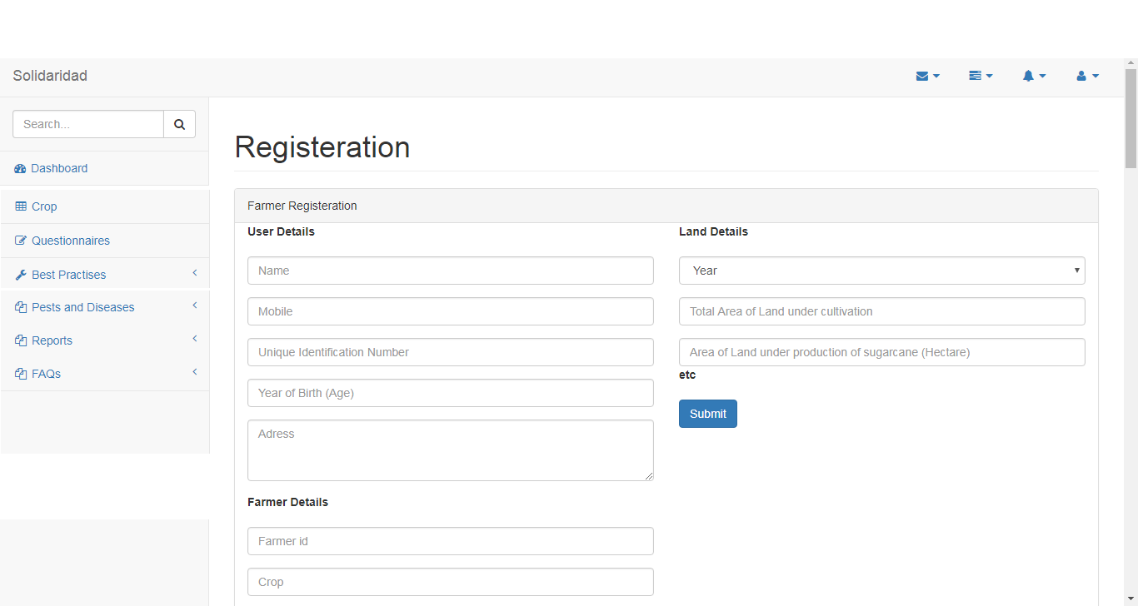

Dashboard:
Display status, score and progress in all areas

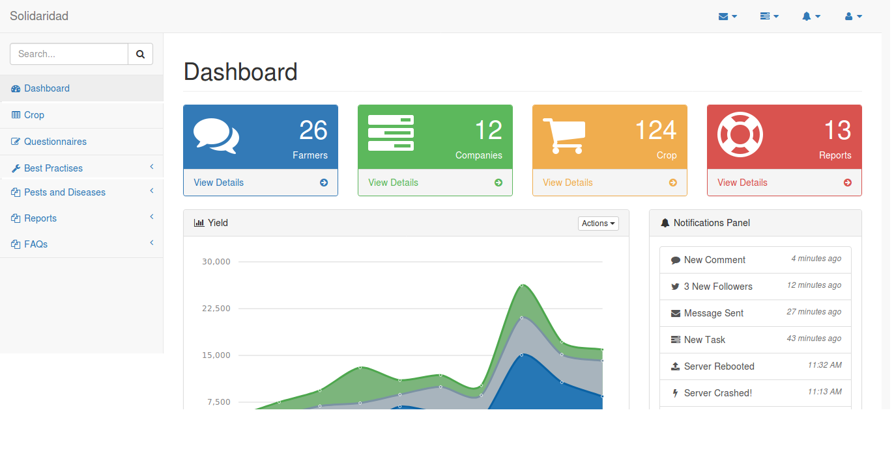

Questionnaire’s:
Famer can fill questionnaire’s for particular crop and he can see the score of certification.
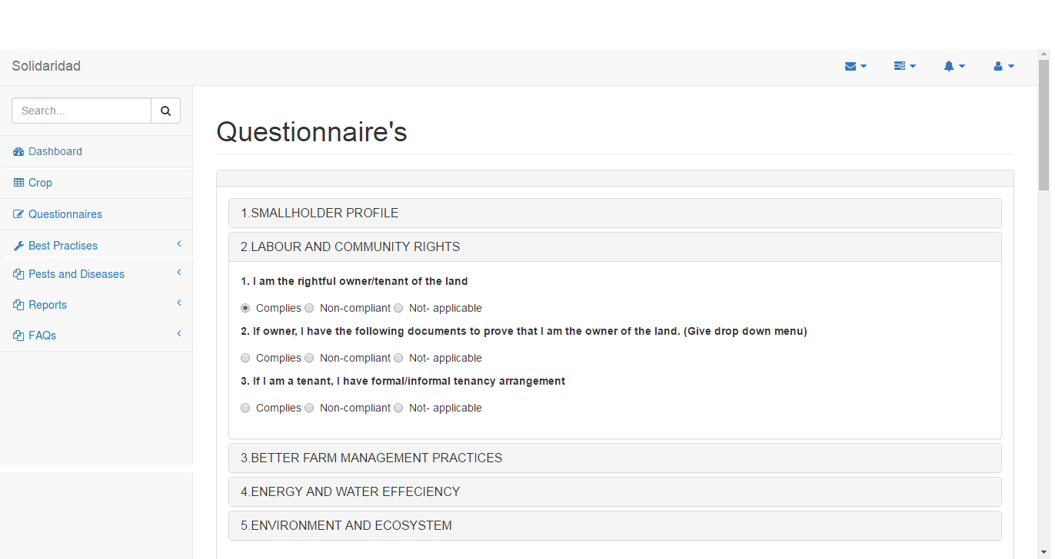

Pests and Diseases:
Informati best practices on of different pests and diseases of crops and precautions to take to avoid those.

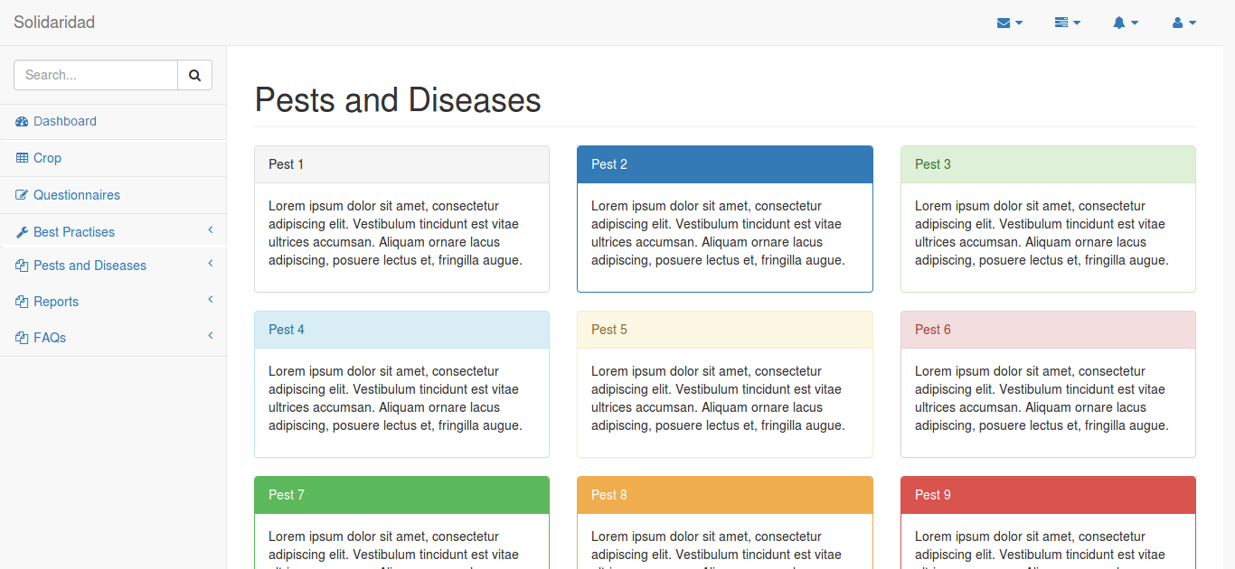

FAQ:
Frequently asked questions
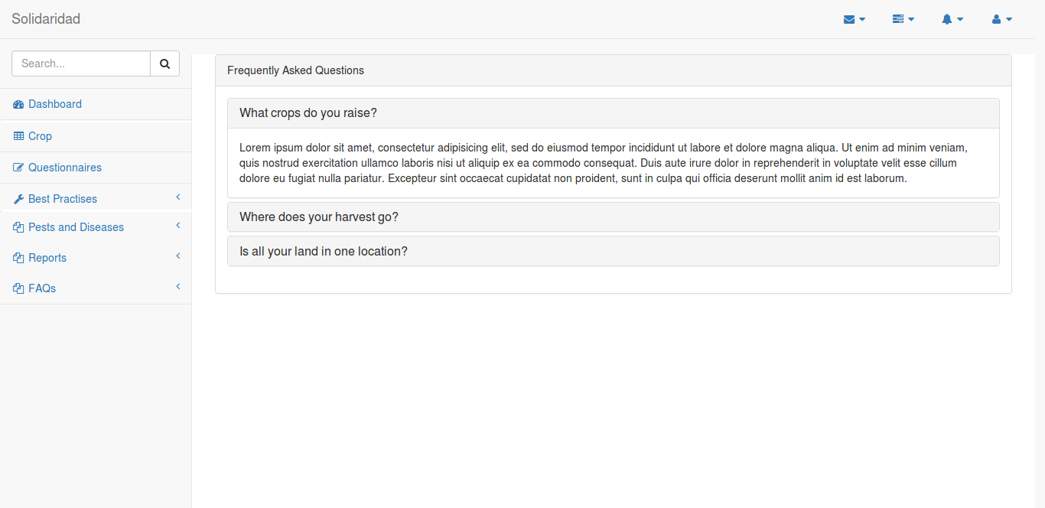

M005 – Representative Area

Dashboard:
Display status, score and progress in all areas
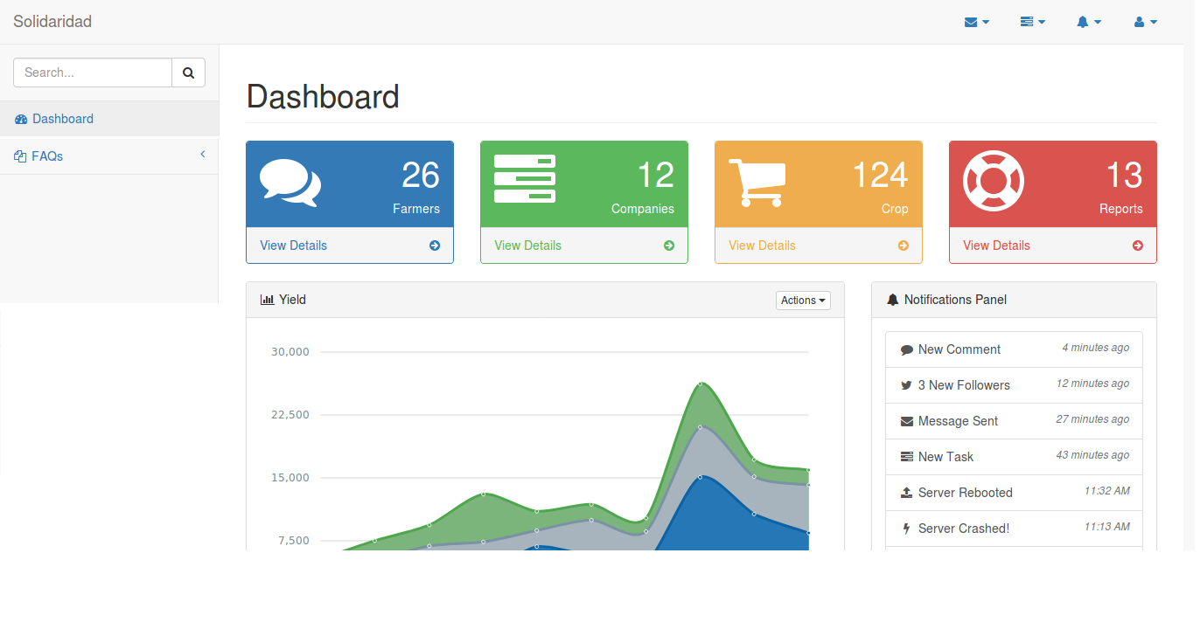

Data Dictionary

Company

Field Name: id
Description: auto increment unique integer
Datatype: numeric
Validation: Not null or zero length
Default Value: Auto generated number

Field Name: name
Description: Title of the Company
Datatype: varchar
Validation: Not null or zero length
Default Value: As entered by user

Field Name: companyTypeId
Description: Company Types
Datatype: int
Default Value: Auto generated number

Field Name: logo
Description: logo for organisation
Datatype: Text
Default Value: As entered by user

Field Name: timezone
Description: general time zone
Datatype: Text
Default Value: As entered by user

Field Name: email_footer
Description: Email footer text
Datatype: Text
Default Value: As entered by user

Field Name: created
Description: Created Date
Datatype: Date
Default Value: current Timestamp

Field Name: updated
Description: Updated Date
Datatype: Date
Default Value: current Timestamp

User

Field Name: id
Description: auto increment unique integer
Datatype: numeric
Validation: Not null or zero length
Default Value: Auto generated number

Field Name: companyId(foreign company_id)
Description: id of user's Company
Datatype: Forigen ID numeric
Validation: Not null or zero length

Field Name: first_name
Description: first name of user
Datatype: varchar
Validation: Not null or zero length
Default Value: As entered by user

Field Name: last_name
Description: last name of user
Datatype: Text
Default Value: As entered by user

Field Name: email
Description: email of user
Datatype: text
Validation: Not null or zero length
Default Value: As entered by user

Field Name: password
Description: password for user
Datatype: Text
Default Value: As entered by user

Field Name: phone
Description: phone number of user
Datatype: Text
Default Value: As entered by user

Field Name: created
Description: created time
Datatype: Datetime
Default Value: autogenerated by system

Field Name: last_login
Description: last login time
Datatype: Datetime
Default Value: autogenerated by system

Field Name: userTypeId(foreign User_type_id)
Description: user type of user
Datatype: Forigen ID numeric
Validation: Not null or zero length
Default Value: As entered by user

Field Name: status (foreign User_type_id)
Description: user status
Default Value: pending

Field Name: updated
Description: Updated Date
Datatype: Datetime
Default Value: current Timestamp

UserType

Field Name: id
Description: auto increment unique integer
Datatype: numeric
Validation: Not null or zero length
Default Value: Auto generated number

Field Name: companyId(foreign company_id)
Description: id of user's organisation
Datatype: Forigen ID numeric
Validation: Not null or zero length

Field Name: user_type
Description: user_types for organisation
Datatype: text
Validation: Not null or zero length
Default Value: As entered by user

Field Name: created
Description: Created Date
Datatype: Date
Default Value: current Timestamp

Field Name: updated
Description: Updated Date
Datatype: Date
Default Value: current Timestamp

CompanyType

Field Name: id
Description: auto increment unique integer
Datatype: numeric
Validation: Not null or zero length
Default Value: Auto generated number

Field Name: Company_id(foreign organisation_id)
Description: id of user's organisation
Datatype: Forigen ID numeric
Validation: Not null or zero length

Field Name: Company_type
Description: request types for Company
Datatype: text
Validation: Not null or zero length
Default Value: As entered by user

Field Name: created
Description: Created Date
Datatype: Date
Default Value: current Timestamp

Field Name: updated
Description: Updated Date
Datatype: Date
Default Value: current Timestamp

Factory

Field Name: id
Description: auto increment unique integer
Datatype: numeric
Validation: Not null or zero length
Default Value: Auto generated number

Field Name: companyId(foreign company_id)
Description: id of user's organisation
Datatype: Forigen ID numeric
Validation: Not null or zero length

Field Name: Factory_name
Description: name of Factory
Datatype: text
Validation: Not null or zero length
Default Value: As entered by user

Field Name: Factory _area
Description: area of Factory
Datatype: numeric
Default Value: As entered by user

Field Name: no_units
Description: no. Of units in Factory
Datatype: numeric
Default Value: As entered by user

Field Name: Factory _phone
Description: phone number of Factory
Datatype: Text
Default Value: As entered by user
Validation: Not null or zero length

Field Name: addressId(foreign address_id)
Description: id of the Address
Datatype: int
Default Value: As entered by user
Validation: Not null or zero length

Field Name: emergency_info
Description: information about energencies
Datatype: text
Default Value: As entered by user

Field Name: comments
Description: comments about Factory
Datatype: text
Default Value: As entered by user

Field Name: attachements
Description: attached files
Datatype: text
Default Value: As entered by user

Field Name: email_footer
Description: footer for emails
Datatype: text
Default Value: As entered by user

Field Name: created
Description: Created Date
Datatype: Date
Default Value: current Timestamp

Field Name: updated
Description: Updated Date
Datatype: Date
Default Value: current Timestamp

QuestionType

Field Name: id
Description: auto increment unique integer
Datatype: numeric
Validation: Not null or zero length
Default Value: Auto generated number

Field Name: Question Type name
Description: Name of question type
Datatype: Text
Validation: Not null or zero length

Field Name: Question Type Abbreviation
Description: Abbreviation of Question Type
Datatype: Text
Validation: Not null or zero length
Default Value: As entered by user

QuestionSection

Field Name: id
Description: auto increment unique integer
Datatype: numeric
Validation: Not null or zero length
Default Value: Auto generated number

Field Name: Section name
Description: Name of Question section
Validation: Not null or zero length
Datatype: Varchar

Field Name: Description
Description: Description of Questioner set
Validation: Not null or zero length
Datatype: Text

Field Name: Position
Description: Position of Questioner set
Validation: Not null or zero length
Datatype: Numeric

Question

Field Name: id
Description: auto increment unique integer
Datatype: numeric
Validation: Not null or zero length
Default Value: Auto generated number

Field Name: questionSectionId
Description: ID of Question Section
Datatype: Numeric (foreign key Questionerset.id)

Field Name: Question
Description: Question Description
Datatype: text
Default Value: As entered by user

Field Name: questionTypeId
Description: ID of Question Type
Datatype: Numeric (foreign key Questiontype.id)

Field Name: Question Guidance
Description: Question Guidance text
Datatype: text
Default Value: As entered by user

Field Name: Question Checklist
Description: Question Checklist text
Datatype: text
Default Value: As entered by user

Field Name: questionCertificationLinkId (foreign key Question Id)
Description: id to which the other questions linked
Datatype: int
Default Value: As entered by user

Field Name: created
Description: Created Date
Datatype: Date
Default Value: current Timestamp

Field Name: updated
Description: Updated Date
Datatype: Date
Default Value: current Timestamp

QuestionOption
Field Name: id
Description: auto increment unique integer
Datatype: numeric
Validation: Not null or zero length
Default Value: Auto generated number

Field Name: OptionName
Description: Name of the option
Datatype: Text
Validation: As entered by user

Field Name: Score
Description: Score associated with the option
Datatype: numeric
Validation: Not null or zero length

QuestionOptionLink

Field Name: id
Description: auto increment unique integer
Datatype: numeric
Validation: Not null or zero length
Default Value: Auto generated number

Field Name: questionId
Description: Name of the option
Datatype: Text
Validation: As entered by user

Field Name: questionOptionId
Description: Score associated with the option
Datatype: numeric
Validation: Not null or zero length

FarmerEvaluation

Field Name: id
Description: auto increment unique integer
Datatype: numeric
Validation: Not null or zero length
Default Value: Auto generated number

Field Name: farmerId(foreign farmerid)
Description: id of farmer answering the question
Datatype: Forigen ID numeric
Validation: Not null or zero length

Field Name: QuestionID(foreign questionID)
Description: id of answered question
Datatype: Forigen ID numeric
Validation: Not null or zero length
Default Value: As entered by user

Field Name: QuestionScore
Description: marks based on the answer to the question
Datatype: Numeric
Validation: Not null or zero length
Default Value: As entered by user

Field Name: created
Description: Created Date
Datatype: Date
Default Value: current Timestamp

Field Name: updated
Description: Updated Date
Datatype: Date
Default Value: current Timestamp

Farmer
Field Name: id
Description: auto increment unique integer
Datatype: numeric
Validation: Not null or zero length
Default Value: Auto generated number

Field Name: Farmer Reg number
Description: unique ID given by factory
Datatype: Alpha numeric
Validation: Not null or zero length

Field Name: UserID (foreign users.userid)
Description: id of user
Datatype: Forigen ID numeric
Validation: Not null or zero length
Default Value: As entered by user

Field Name: Farmer Gender
Description: Gender of the Farmer
Datatype: text
Default Value: As entered by user

Field Name: Farmer State Id(foreign state.stateid)
Description: State of the Farmer
Datatype: text
Default Value: As entered by user

Field Name: Farmer District Id(foreign district.districtid)
Description: District of the Farmer
Datatype: text
Default Value: As entered by user

Field Name: Farmer Thasil id(foreign taluk.talukid)
Description: Thasil of the Farmer
Datatype: text
Default Value: As entered by user

Field Name: Farmer Village(foreign village.villageid)
Description: Village of the Farmer
Datatype: text
Default Value: As entered by user

Field Name: Farmer Address Pincode
Description: Address Pincode of the Farmer
Datatype: text
Default Value: As entered by user

Farmers Land Details

Field Name: id
Description: auto increment unique integer
Datatype: numeric
Validation: Not null or zero length
Default Value: Auto generated number

Field Name: FarmerID
Description: Foreign key from Farmer table
Datatype: numeric
Validation: Not null or zero length

Field Name: Total_land_Cultivation
Description: Total land under cultivation
Datatype: numeric
Validation: Not null or zero length

Field Name: Land_Cultivation_Sugarcane
Description: Land under cultivation for production of sugarcane
Datatype: numeric
Validation: Not null or zero length

Field Name: otherCropId (foreign crop.cropId)
Description: Crops cultivated other than sugarcane
Datatype: Text
Validation: As entered by user

Field Name: Average_Yield_Sugarcane
Description: Average yield of sugarcane
Datatype: numeric
Validation: Not null or zero length

Field Name: Regular_labour
Description: Regular labour
Datatype: numeric
Validation: Not null or zero length

Field Name: Seasonal _labour
Description: Seasonal labour
Datatype: numeric
Validation: Not null or zero length

Field Name: Sugarcane_supply
Description: Sugarcane supply to factor or others
Datatype: Text
Validation: As entered by user

Field Name: irrigationId (foreign irrigation.irrigationId)
Description: Source of irrigation
Datatype: Text
Validation: As entered by user

Field Name: Sugarcane Planting ear
Description: Sugarcane Planting year
Datatype: Datetime
Default Value: As entered by user

Field Name: Crop Year
Description: Sugarcane Crop yield year
Datatype: Datetime
Default Value: As entered by user

Field Name: Harvesting month
Description: Sugarcane Harvesting month
Datatype: Datetime
Default Value: As entered by user

Certification
Field Name: id
Description: auto increment unique integer
Datatype: numeric
Validation: Not null or zero length
Default Value: Auto generated number

Field Name: CompanyId (foreign company.companyId)
Description: Company to which certification belongs
Datatype: Text
Validation: Not null or zero length
Default Value: As entered by user

Field Name: Certification Name
Description: Name of the certification
Datatype: Text
Validation: Not null or zero length
Default Value: As entered by user

Field Name: Certification Year
Description: Certification for the year
Datatype: Datetime
Default Value: As selected by user

Field Name: CropId (foreign Crop.cropId)
Description: Certification for the crop
Datatype: Text
Default Value: As selected by user

AppModules

Field Name: id
Description: auto increment unique integer
Datatype: numeric
Validation: Not null or zero length
Default Value: Auto generated number

Field Name: Module Name
Description: Name of the Module
Datatype: Text
Validation: Not null or zero length
Default Value: As entered by user

Field Name: Module Abbrevation
Description: Abbrevation of the module
Datatype: Text
Validation: Not null or zero length
Default Value: As entered by user

UserPermission

Field Name: id
Description: auto increment unique integer
Datatype: numeric
Validation: Not null or zero length
Default Value: Auto generated number

Field Name: ModuleID
Description: Forign key of module
Datatype: Numeric
Validation: Not null or zero length

Field Name: usertypeid
Description: Forign key of usertypes
Datatype: Numeric
Validation: Not null or zero length

State

Field Name: id
Description: auto increment unique integer
Datatype: numeric
Validation: Not null or zero length
Default Value: Auto generated number

Field Name: Statename
Description: Name of the state
Datatype: Text
Validation: Not null or zero length

District

Field Name: id
Description: auto increment unique integer
Datatype: numeric
Validation: Not null or zero length
Default Value: Auto generated number

Field Name: DistrictName
Description: Name of the District
Datatype: Text
Validation: Not null or zero length

Field Name: State Id (foreign state.state id)
Description: state id to which the district belongs
Datatype: Text
Validation: Not null or zero length

Taluk

Field Name: id
Description: auto increment unique integer
Datatype: numeric
Validation: Not null or zero length
Default Value: Auto generated number

Field Name: Taluk Name
Description: Name of the Taluk
Datatype: Text
Validation: Not null or zero length

Field Name: Dsitrict Id (foreign district.district id)
Description: Dsitrict id to which the taluk belongs
Datatype: Text
Validation: Not null or zero length

Village

Field Name: id
Description: auto increment unique integer
Datatype: numeric
Validation: Not null or zero length
Default Value: Auto generated number

Field Name: Village Name
Description: Name of the Village
Datatype: Text
Validation: Not null or zero length

Field Name: Taluk Id (foreign taluk.taluk id)
Description: taluk id to which the village belongs
Datatype: Text
Validation: Not null or zero length

Crop

Field Name: id
Description: auto increment unique integer
Datatype: numeric
Validation: Not null or zero length
Default Value: Auto generated number

Field Name: Crop name
Description: Name of the Crop
Datatype: Text
Validation: Not null or zero length

Irrigation

Field Name: id
Description: auto increment unique integer
Datatype: numeric
Validation: Not null or zero length
Default Value: Auto generated number

Field Name: Irrigation Name
Description: Source of irrigation
Datatype: Text
Validation: Not null or zero length

Address

Field Name: id
Description: auto increment unique integer
Datatype: numeric
Validation: Not null or zero length
Default Value: Auto generated number

Field Name: Address Line 1
Description: Address Details
Datatype: Text
Validation: Not null or zero length

Field Name: Address Line 2
Description: Address Details
Datatype: Text
Validation: Not null or zero length

Field Name: Taluk Id(foreign taluk.talukid)
Description: Address Details -Taluk
Datatype: Numeric
Validation: Not null or zero length

Field Name: State Id(foreign taluk.talukid)
Description: Address Details -State
Datatype: Numeric
Validation: Not null or zero length

Field Name: Pincode
Description: Address Details -Pincode
Datatype: Numeric
Validation: Not null or zero length

Database Schema

